**CogoPort Assignment API Documentation**

API’S to develop a robust and scalable FastAPI application to manage a Configuration Management system for onboarding Organizations from each country.

**Base_URL:**

Base URL for the API is <http://localhost:8000>

**Authentication:**

No Authentication Method is used in it

**Error Handling:**

• **Exception Handling**: FastAPI leverages Python's try-except blocks to catch exceptions that may occur during request processing.

• **HTTP Status Codes**: Errors are associated with appropriate HTTP status codes (e.g., 400 for client errors, 500 for server errors) to indicate the nature of the problem.

• **Error Response Models**: FastAPI uses Pydantic models to define structured error responses, ensuring consistency in the format of error messages returned to clients.

**Exception Handling:**

* Custom exception classes for specific error scenarios are inherited from built-in or FastAPI’s HTTPException.
* Handle errors within specific route handlers by raising exceptions or using try-except blocks.
* Backend uses standard HTTP status codes to indicate the nature of errors. For example, 404 for "Not Found", 400 for "Bad Request", 500 for "Internal Server Error", etc.

**API Routes:**

1.) Create a Configuration: ROUTE FOR Creating Configuration

**POST** /api/create_configuration

Request Body: Response: 200 OK on success, returns:

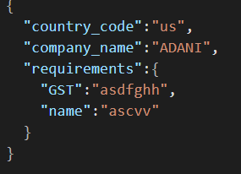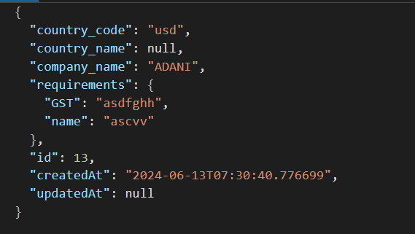

2.) Get Specific Configuration: ROUTE FOR Creating Config via country_code

**GET** /api/get_configuration/{country_code}

Response: 200 OK on success, returns: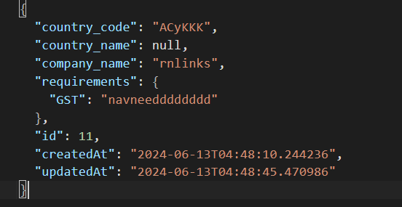

**­**

3.) Update Specific Config. : ROUTE FOR Updating Config via country_code

**POST** /api/update_configuration

Request Body: Response: 200 OK on success, returns:

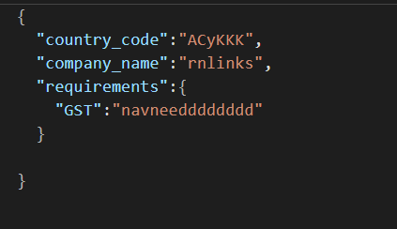 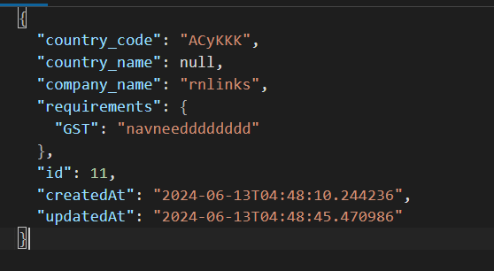

4.) DELETE Specific Config.: ROUTE FOR Deleting Config via country_code

passed via query

**DELETE**  /api/delete_configuration?country_code=IND

Response: 200 OK on success, returns: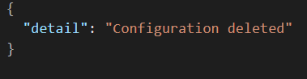

**Error Scenario:**

1.) Trying to delete, update or get a Configuration which doesn’t exit then response is 400 Returning not found Cases.

**RESPONSE**: 400 returns

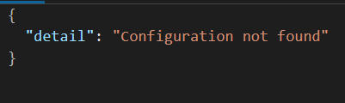

2.) Trying to add a Configuration which already exit:

**RESPONSE**: 400 returns

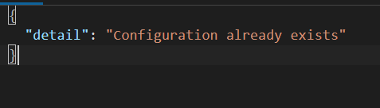

**Summary:**

This API Documentation provides a clear overview of the endpoints, their methods, expected inputs, and possible outputs for managing tasks through the API. Adjustments can be made based on specific application requirements and conventions.